Final Assignment – Project Management

Project management utility to help manager to track projects, tasks and associated users on it.

Utility has following four different screens

1. Add Users : allow to add users pool
2. Add Project: allows to add new project and assign the project manager from the user pool from above functionality)
3. Add Task : allows to add new task details and assign to project
4. View Task: View list of tasks associated with specific project or all the existing list of projects.

Project is divided into two parts, Project management front end web application and Web API services.

**Part – 1 Web app**

1. Add new project

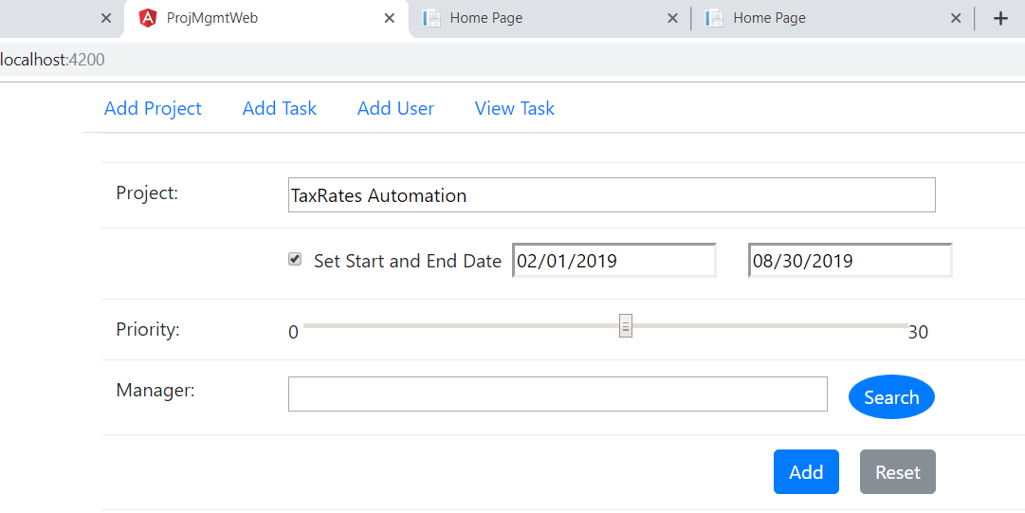

1. After adding it will display the list of created project on the same screen

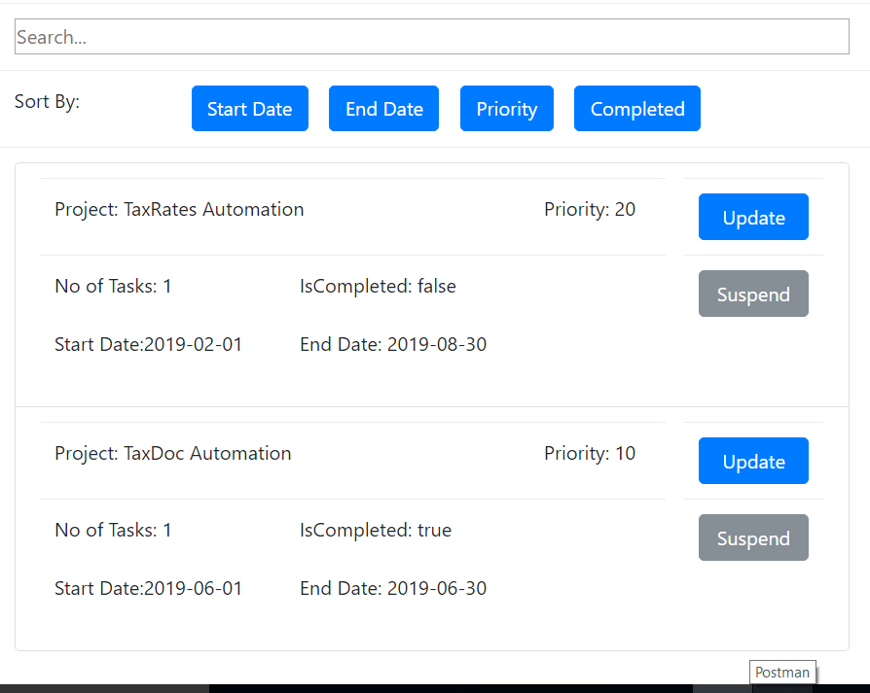

1. Filter the project based on the name

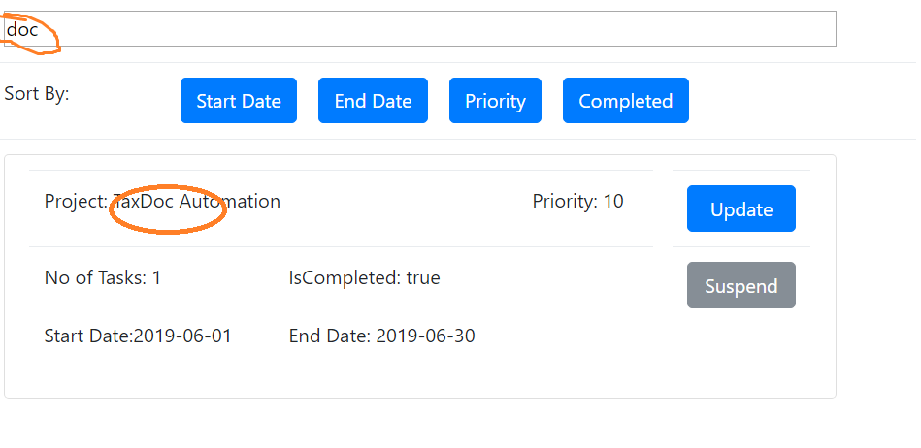

1. Also supports sorting functionality by Start date, End date, priority and completion status of the project.

Add User:

Like above screen, Add user menu allow to add/Edit/Delete the uses

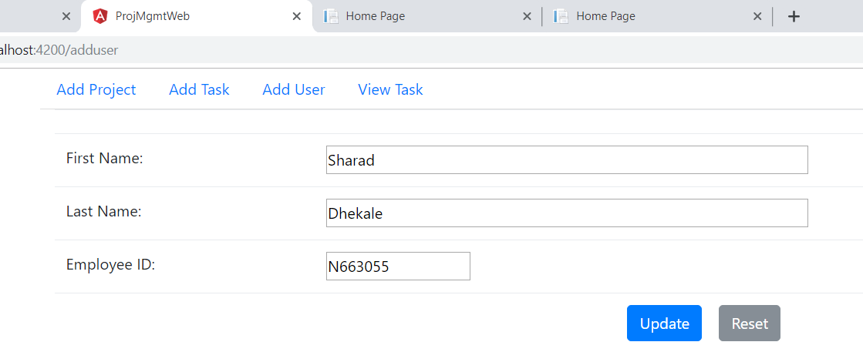

User list is displayed on the same screen

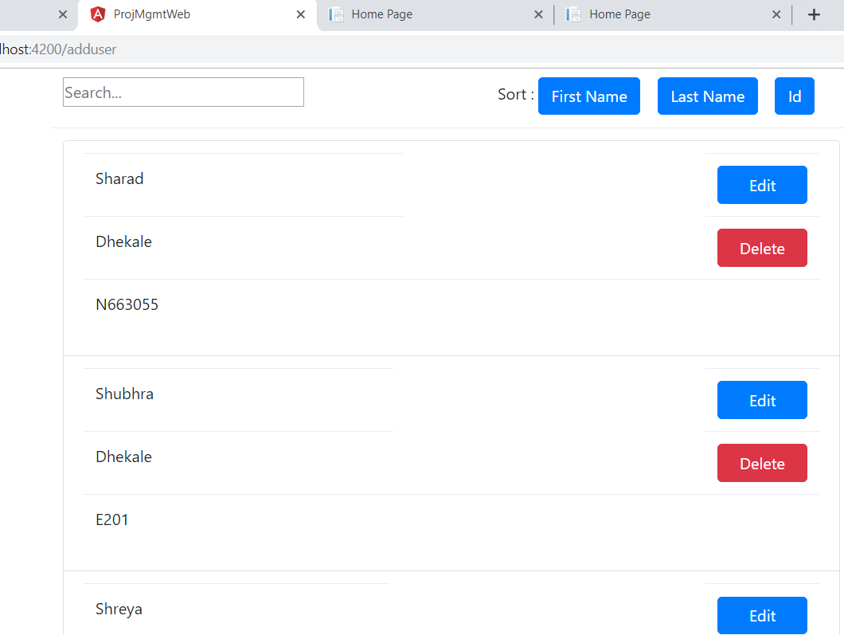

Add Task Screen:

Allowing to add new task based on selected project and user

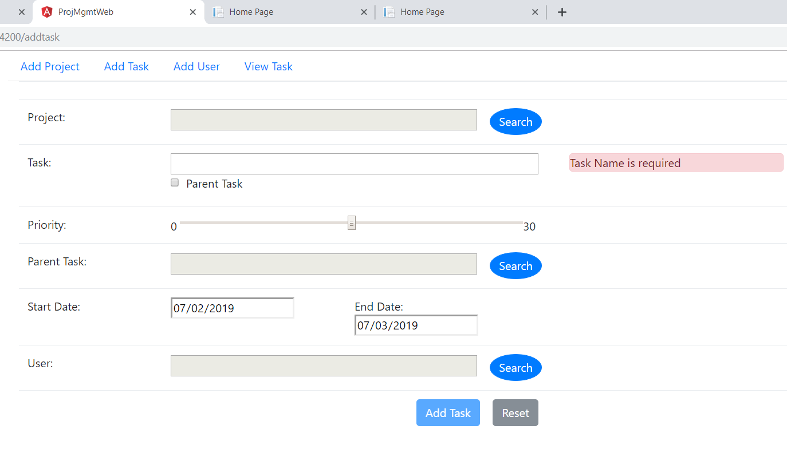

View Task, separate menu item to display the task list.

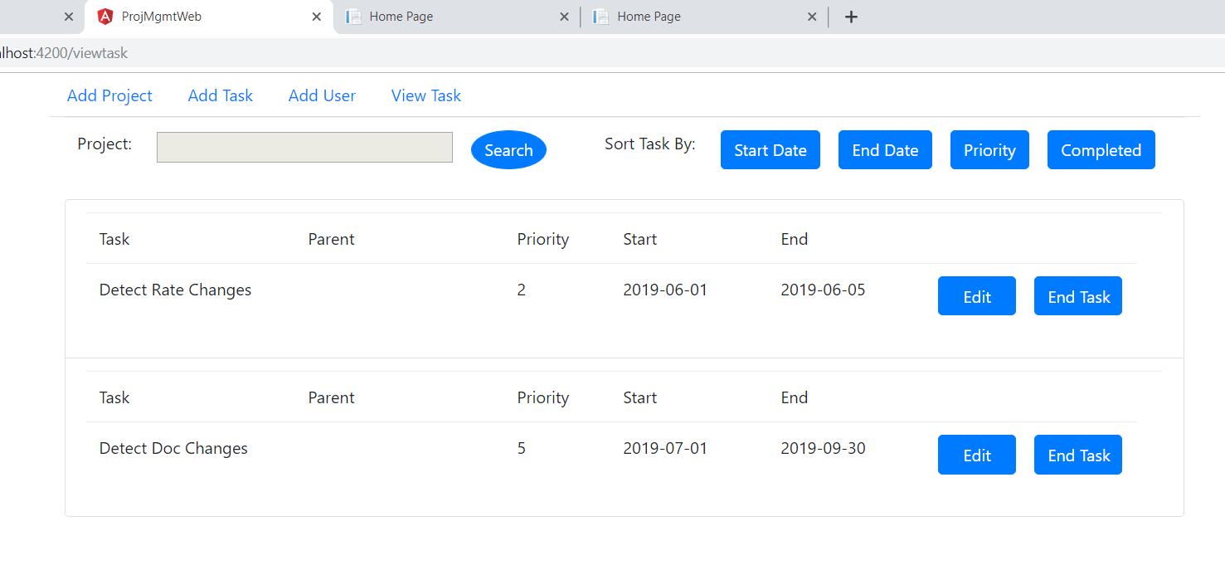

**Part – 2 Web API Services**

Created web api project and added three api controller’s for Project, Task and user also added test project for unit testing.

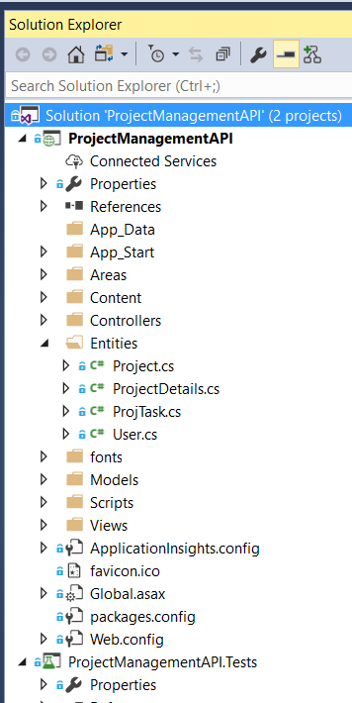

Added CURD operations GET/PUT/POST and DELETE operations for each controller Project, Task and Users controller.

Sample code snippet for user controller

